Week 4 Workshop Solution
Project Title: AI-Powered Personal Health Assistant
Team Members: Anthony Sutan Lie (Team Lead), Sakshi Saini, Prathyusha Biradar
1. System Requirements
Analyzing the Level 1 Use Case Diagram, the user goals are converted into high-level software application system requirements:
- SR1 (User Identity & Goal Management): The system shall manage user identification, biometric profiles, health goals, and dietary restrictions securely.
- SR2 (Wearable & Health Data Processing): The system shall ingest, normalize, and store multi-metric wearable health data (steps, heart rate, sleep, active calories).
- SR3 (Contextual AI Recommendation Engine): The system shall synthesize historical biometric data with domain knowledge using Retrieval-Augmented Generation (RAG) to generate personalized diet and exercise plans.
- SR4 (Conversational AI Assistant): The system shall provide a real-time, interactive chat interface capable of answering general health and wellness questions.
- SR5 (Mental Health & Mindfulness Module): The system shall deliver AI-generated mindfulness guides and motivational feedback based on active user engagement and reported mood.
- SR6 (Cross-Platform Mobile Interface): The system shall deliver an accessible mobile interface for Android and iOS devices.

2. Functional Requirements (by Subsystem & Owner)
Expanding the system requirements into specific functional capabilities allocated to each team member:
A. Sakshi Saini — User Management & Data Integration Subsystem
- FR1.1 (User Registration & Authentication): The system shall allow users to register, log in, log out, and reset credentials via Firebase Authentication.
- FR1.2 (Biometric Profile Management): The system shall enable users to input and update personal profile attributes (age, weight, height, dietary restrictions, medical conditions).
- FR1.3 (Goal Configuration): The system shall allow users to create, update, and monitor custom health targets (e.g., target weight, daily step count, target sleep hours).
- FR2.1 (Wearable Ingestion API): The system shall provide API endpoints to ingest time-series wearable data (steps, heart rate, sleep metrics, calories burned).
- FR2.2 (Data Storage & Historical Logging): The system shall store ingested device logs in PostgreSQL, linked to the user’s account ID.
- FR2.3 (Progress Summarization): The system shall compute daily and weekly metric averages to generate trend summaries for the dashboard.
B. Anthony Sutan Lie — Recommendation Engine Subsystem
- FR3.1 (Contextual RAG Retrieval): The system shall query vector embeddings stored in PostgreSQL (pgvector) to retrieve relevant nutritional and physical fitness knowledge matching user profiles.
- FR3.2 (Diet Plan Generation): The system shall process retrieved user context and health goals through the GenAI engine to generate daily meal recommendations adhering to dietary constraints (e.g., vegan, keto, allergies).
- FR3.3 (Exercise Plan Generation): The system shall generate daily workout plans customized to the user’s fitness level, target goals, and current activity history.
- FR3.4 (Recommendation History Caching): The system shall store generated plans in the database for tracking, comparison, and offline review.

C. Prathyusha Biradar — Chatbot & Mental Health Subsystem
- FR4.1 (Real-Time AI Chatbot): The system shall provide an interactive conversational UI that routes user queries to the Anthropic Claude API for health advice.
- FR4.2 (Conversation State & History): The system shall maintain conversation history to preserve context across chat interactions.
- FR5.1 (Mindfulness Content Generation): The system shall generate custom mindfulness exercises and relaxation routines based on user-reported stress or mood levels.
- FR5.2 (Motivational Messaging): The system shall trigger automated motivational alerts based on wearable goal achievements.
- FR5.3 (Safety Guardrails & Crisis Intervention): The system shall monitor input text for self-harm or high-risk health keywords and automatically display crisis disclaimers and emergency helpline contacts.

3. Non-Functional Requirements
Defining performance, security, usability, and operational standards based on user needs and data characteristics:
- NFR1 (Performance & Latency): AI-generated recommendations and chatbot responses must return within $5\text{ s}$ under normal network conditions. Mobile dashboard data loading must complete within $1.5\text{ s}$.
- NFR2 (Security & Encryption): All network communications must use TLS 1.3 encryption. Personal biometric data stored in PostgreSQL must be encrypted at rest using AES-256. User credentials must be managed via Firebase Auth.
- NFR3 (Privacy & Compliance): The application must adhere to Australian Privacy Principles (APPs), requiring explicit user consent before processing biometric data and prohibiting third-party data sharing.
- NFR4 (Usability & Accessibility): The mobile application must comply with WCAG 2.1 Level AA standards, incorporating dynamic font scaling, high contrast, and accessible UI controls.
- NFR5 (Reliability & Availability): The system must maintain $99.5\%$ service availability. If external GenAI APIs encounter rate limits or outages, the application must display pre-cached advice and user-friendly error messages.
- NFR6 (Scalability): The backend API gateway and database connection pool must support scaling up to $10,000$ concurrent active users without degradation in performance.
- NFR7 (Ethical AI & Medical Disclaimer): AI recommendations must include explicit disclaimers confirming that outputs are for informational purposes only and do not replace professional medical advice.

4. Quality Standards & Metrics
Mapping non-functional requirements to software quality standards and quantifiable target metrics:
NFR Category | Governing Quality Standard | Target Metric / Indicator | Acceptance Threshold
Performance | ISO/IEC 25010 Quality Model | Latency & Response Speed | - Chat/Recommendation output: $≤5\text{ s}$  - API Data Fetch: $≤500\text{ ms}$  - Page render: $≤1.5\text{ s}$
Security | OWASP Mobile Top 10 | Security Compliance & Encryption | - $100\%$ HTTPS/TLS 1.3 coverage  - Zero high-risk OWASP vulnerabilities
Usability | ISO 9241-11 Usability Baseline | System Usability Scale (SUS) Score | - SUS score $≥80/100$  - First-time task completion rate $≥90\%$
Reliability | IEEE 730 Software QA Standard | System Uptime & Failure Rate | - Operational Uptime $≥99.5\%$  - Unhandled API error rate $<0.5\%$
Ethical AI | Ethically Aligned Design Standard | Keyword Detection & Disclaimer Trigger | - $100\%$ trigger rate on predefined crisis keywords  - Medical disclaimer displayed on all AI outputs

5. System Architecture
Defining the architectural paradigm, layer responsibilities, and structural breakdown:
Architecture Type: 3-Tier Layered Client-Server Architecture
The system adopts a 3-Tier Layered Client-Server Architecture augmented with an external Microservices/API Gateway pattern for GenAI and Authentication services.
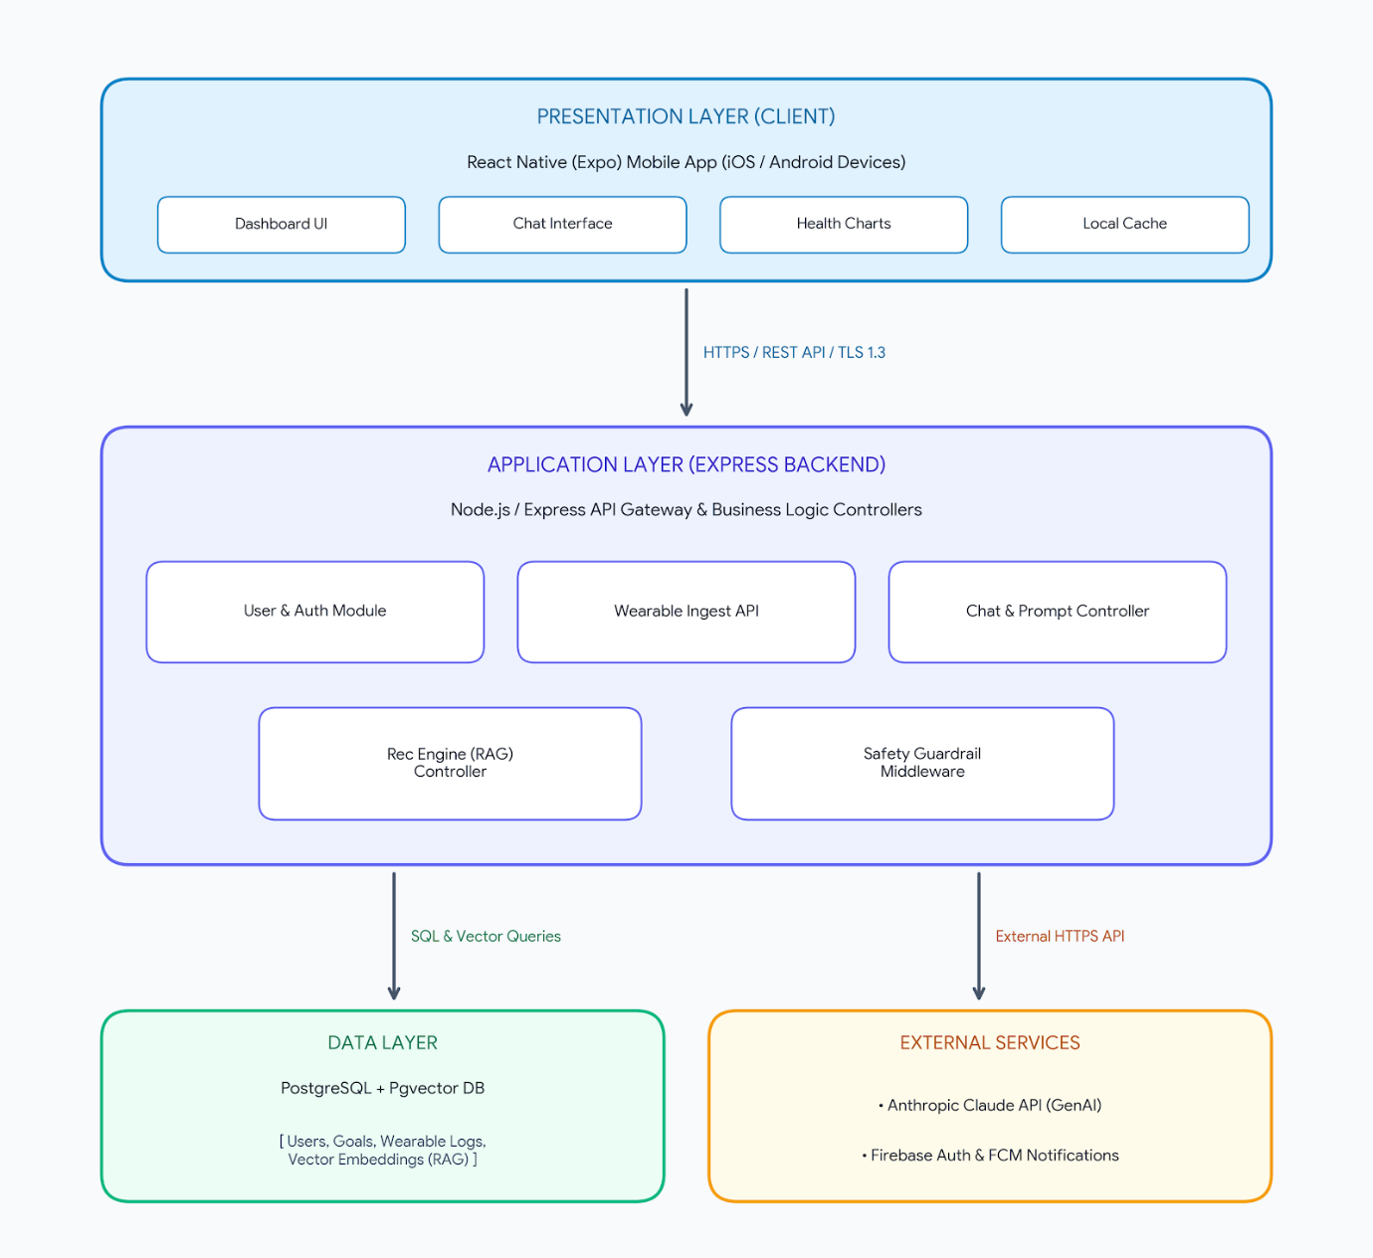
Layer Responsibilities
- Presentation Layer (Mobile App): Built using React Native (Expo) to provide a cross-platform mobile user interface. Handles local state management, health trend visualization, and user interactions.
- Application Layer (Backend API): Built using Node.js and Express. Serves as the central API gateway managing data transformations, business rules, safety filtering middleware, and prompt orchestration.
- Data Layer (PostgreSQL + Pgvector): Centralized database managing relational data (user profiles, health goals, activity logs) alongside vector embeddings used for similarity searches during RAG execution.
- External Services:
  - Firebase Authentication & FCM: Manages secure login sessions and delivers push notifications.
  - Anthropic Claude API: Executes core reasoning for personalized diet/exercise recommendations, chat responses, and mindfulness exercises.

